# Task 2 – Windows File Sharing

#### Simple File Sharing (using Windows XP SP3)

1. Start VMWare Player on the lab computer. When prompted for an environment, select the Windows XP SP3 option. Wait until it boots.
2. Creating a share using simple file sharing:
   1. When presented with the desktop, right click the desktop and create a new folder. Name this folder “Month” where month corresponds with the month you were born (January).

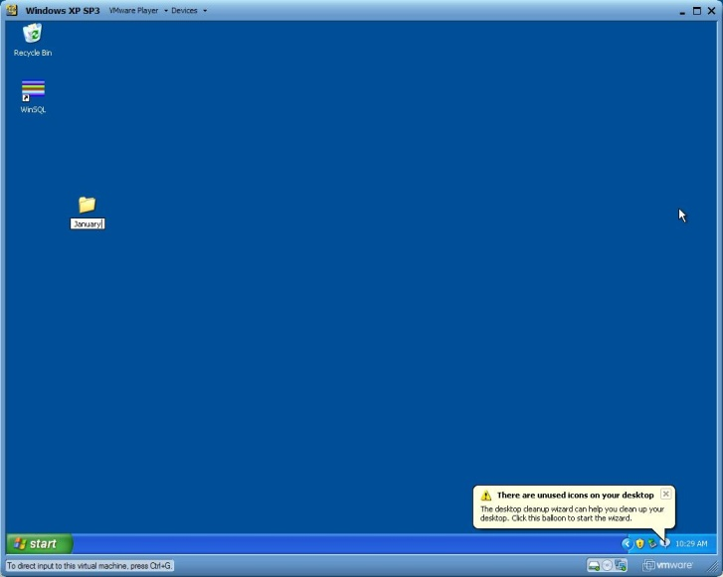

* 1. Within this new folder, create a text file called “Test.txt”. Within this text file enter some data. This is simply so we can verify read and write capabilities.
  2. Right click this folder and click “Sharing and Security”. A new modal window appears.

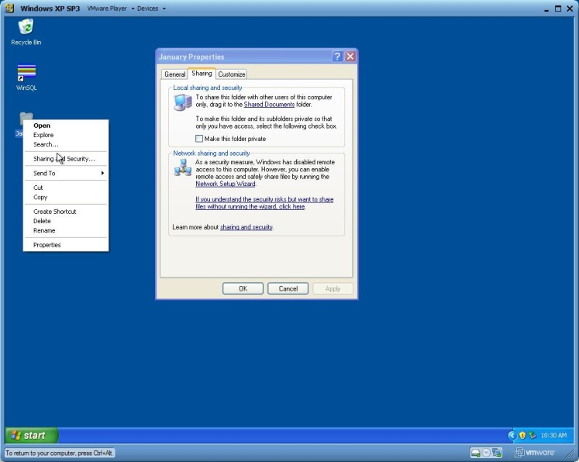

* 1. Under a default Windows XP installation File and Folder sharing is turned off initially. Click the blue text reading “If you understand the security risks but want to share files without running the wizard, click here”. A new window appears asking whether you want to run the wizard or not. Click “Just enable file sharing”. This turns on File and Folder sharing.
  2. Tick the box “Share this folder on the network”. This allows other users to read and view the files and folders contained in January. We want files and folders to be written as well as read so tick the box “Allow network users to change my files”. This enables read and write execution on the files and folders contained within January.

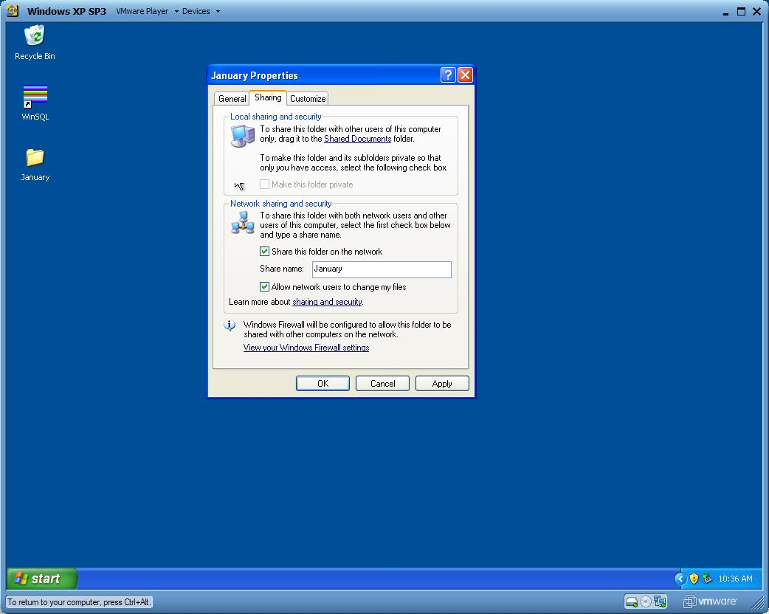

* 1. To map the folder to a free drive letter on the virtual machine open a new explorer window using the shortcut Windows Key + E, or clicking My Computer from the start menu. Navigate to the Desktop.
  2. When at the Desktop, click at the top of the window and click Tools > Map Network Drive.

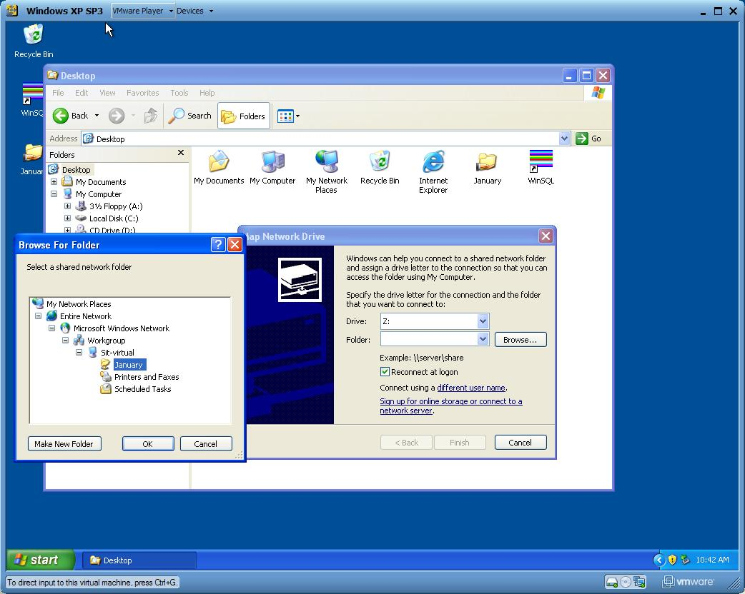

* 1. Select a free drive letter (Z) and browse for the folder. Select the recently shared folder. It will be located under the PC’s name within the Windows Workgroup.

1. Verify read and write capability to our newly create simple share:
   1. To access the share from another computer we must use it’s IP address. To get this, we use a simple windows command (based on the older unix command) ipconfig. This presents us with the ipaddresses and information about the various networking adapters, gateways and connections present on the system. To access ipconfig, open the command prompt by clicking the start menu > Run > cmd.exe.

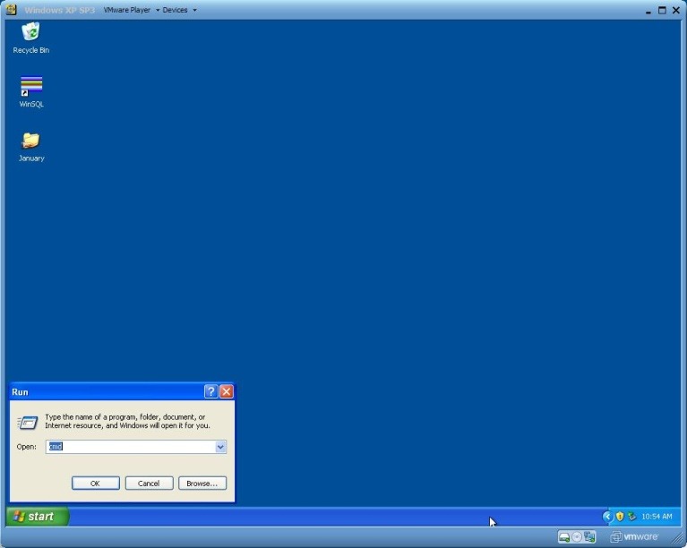

* 1. From the command window, enter the command “ipconfig”. We are concerned with the address labeled “IP Address” under the Local Area Connection (the only network adapter of this virtual machine. Take not of this address somewhere.

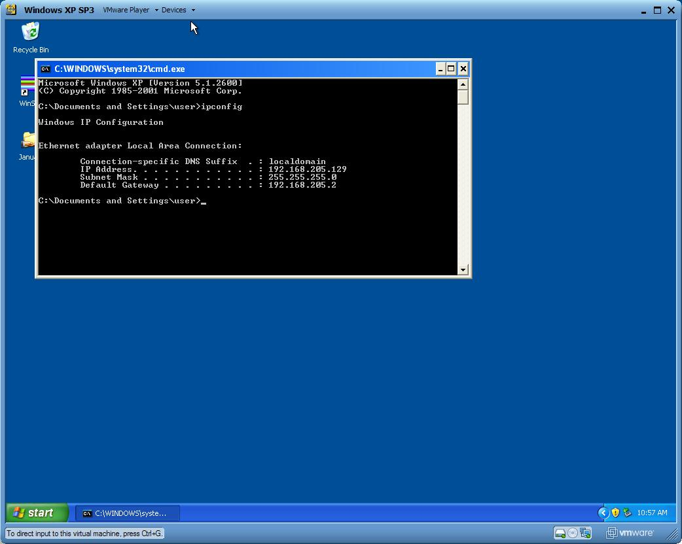

* 1. Move your focus back to the host machine, and create a new explorer window using the shortcut (Windows key + E) or Start menu > My Computer.
  2. In the address bar enter the ipaddress PRECEDED by the characters “\\”. This indicates a network address. I.e. \\192.168.0.1
  3. Once the network share has been presented, the folder we shared previously should appear. Click it, and check to see the text file we creates is present.
  4. To verify write permission, open it, append some text and try and save it. If you do not have permission, an error dialog box will be presented.

1. Close VMWare player.

#### Advanced File Sharing (using Windows Server 2003)

1. Start VMWare Player on the lab computer. When prompted for an environment, select the Windows Server 2003 option. Wait until it boots.
2. Creating the 2nd share using advanced file sharing:
   1. When presented with the desktop, right click the desktop and create a new folder. Name this folder “Name” where name corresponds with the first 8 characters of your first and last name concatenated without spaces (DominicB).
   2. Within this new folder, create a text file called “Test.txt”. Within this text file enter some data. This is simply so we can verify read and write capabilities.
   3. To share this folder using advanced file sharing, we need to create a new user. Access the user management service by clicking the Start menu > Run >lusrmgr.msc . This control panel allows one to create, delete and manage user accounts within the environment. Create a new user named “Name” where name corresponds with the first 8 letters of your first name (Dominic). Set the password to anything (sharedaccount) – a null password field errors. Close this window.
   4. Once the new user has been created, permissions must be given so they can access the folder. Right click the folder you created in the previous step, and click Sharing and Security. Tick the radio button labeled “Share the folder”. This shares the folder, however does not give permissions.
   5. To give the user we created permissions, click the “Permissions” button on the Sharing and Security tab. Click “Add” and enter the users name as above (Dominic). Once the user has been added, tick the boxes “Change” and “Read”. This allows the user to modify files, as well as read. Apply changes.
   6. The folders security permissions must also be changed to allow access. Click the “Security” tab under the folders properties and add the user in an identical manner as the step above. Make sure to tick the “Modify” (allows changes to existing files) and “Write” (allows new files to be created) checkboxes are ticked. Apply changes.
   7. To map the folder to a free drive letter on the virtual machine open a new explorer window using the shortcut Windows Key + E, or clicking My Computer from the start menu. Navigate to the Desktop.
   8. When at the Desktop, click at the top of the window and click Tools > Map Network Drive.
   9. Select a free drive letter (X) and browse for the folder. Select the recently shared folder. It will be located under the PC’s name within the Windows Workgroup. Click OK.
3. Verify read and write capability to our newly create advanced file share:
   1. Follow the steps contained within step 4. a.) to d.).
   2. A prompt will appear asking for your username and password. Enter the VMWares virtual machines computer name followed by the username. E.g. “QUT-ILQYGIDJC6U\Dominic”. Use the password you entered in the previous steps (shared account).
   3. To verify write permission, open it, append some text and try and save it. If you do not have permission, an error dialog box will be presented.
4. Close VMWare player.